|  |  |  |
| --- | --- | --- |
| **MODULE:** 14 | **LESSON:** 1 | DISTANCE IN THE COORDINATE PLANE |

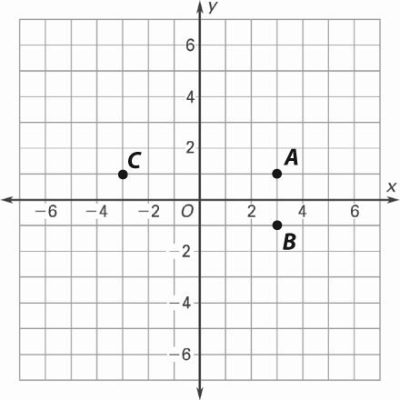Reflecting a Point

In this lesson, a point on a coordinate plane is reflected across the axes of the coordinate plane. The points *B* and *C* are reflections of point *A* across the *x*- and *y*-axes.

The coordinates of point *A* are (3, 1).

Point *B* is the reflection of point *A* across the *x*-axis.

Point *C* is the reflection of point *A* across the *y*-axis.

The following rules can help you find the coordinates of a reflected point by looking at the signs of the coordinates.

|  |  |
| --- | --- |
| Reflecting across the *x*-axis  “Reflect across *x.* MSM15_AN_ArrowChange the *y*.”  In this example, point *A*’s *x*-coordinate, 3, stays the same when point *A* is reflected across the *x*-axis to become point *B*. Point *A*’s *y*-coordinate, 1, switches to 1 to become point *B*.  So, point *B*’s coordinates are (3, 1). | Reflecting across the *y*-axis  “Reflect across *y.* MSM15_AN_ArrowChange the *x*.”  In this example, point *A*’s *y*-coordinate, 1, stays the same when point *A* is reflected across the *y*-axis to become point *C*. Point *A*’s *x*-coordinate, 3, switches to 3 to become point *C*.  So, point *C*’s coordinates are (3, 1). |

|  |  |
| --- | --- |
| Distance between Points  The distance between two points on a coordinate plane depends on whether their *x*- or  *y*-coordinates are different. Look at the points on the grid above to solve the problems. | |
| The distance between points *A* and *B* is  the absolute value of the difference of the  *y*-coordinates of the points. | The distance between points *A* and *C* is  the absolute value of the difference of the  *x*-coordinates of the points. |